
TEMASEK JUNIOR COLLEGE

CHEMISTRY 9647/01
Paper 1 Multiple Choice

Tuesday 21st SEPTEMBER 2010 1 hour

Additional materials: Data Booklet
Multiple Choice Answer Sheet

READ THESE INSTRUCTIONS FIRST

Do not open this booklet until you are told to do so.

Write in soft pencil.
Do not use staples, paper clips, highlighters, glue or correction fluid.
Write your name, index number and CG on the Answer Sheet in the spaces provided.

There are forty questions on this paper. Answer all questions. For each question, there are four possible answers labelled A, B, C, and D.
Choose the one you consider correct and record your choice in soft pencil on the separate Answer Sheet.

Read the instructions on the Answer Sheet very carefully.

Each correct answer will score one mark. A mark will not be deducted for a wrong answer.
Any rough working should be done in this booklet.
You may use a calculator.

Section A
For each question there are four possible answers, A, B, C and D. Choose the one you consider to be correct.
1 | A 0.200 g sample was dissolved in an excess of sulfuric acid, forming a solution containing iron(II) sulfate and nickel(II) sulfate. On titration, this solution required 19.6 cm³ of 0.020 mol dm⁻³ potassium manganate(VII) to oxidize all the iron. Calculate the percentage of iron in the sample.
 | A | 11 % |  |  | B |  |  | 25 % |  |  |  | C |  |  |  | 55 % |  |  | D |  |  | 64 %
2 | A 100 % conversion of an oxide of nitrogen to ammonia and water has taken placed according to the equation below:  H₂ (g), catalyst  N_{x}O_{y} xNH₃ + yH₂O  2400 cm³ of nitrogen oxide, measured at room temperature and pressure (r.t.p), produced 7.20 g of water. The ammonia produced was neutralized by 200 cm³ of 1.0 mol dm⁻³ HCl. What was the oxidation number of the nitrogen in the nitrogen oxide?
 | A | +1 |  |  | B |  |  | +2 |  |  |  | C |  |  |  | +3 |  |  | D |  |  | +4
3 | Which of the following formulae represents a particle with the composition 1 proton, 1 neutron and 2 electrons?  (D represents deuterium, ²H)
 | A | D |  |  | B |  |  | D⁻ |  |  |  | C |  |  |  | H⁻ |  |  | D |  |  | He
4 | Oxygen reacts with platinum(VI) fluoride, PtF₆, as follows:  O₂ + PtF₆ O₂⁺ PtF₆⁻  It was suggested that xenon should react similarly and, in this way, the first noble gas compound was produced.  Xe + PtF₆ Xe⁺ PtF₆⁻  What is the most likely reason for the suggestion being made?
 | A |  | O and Xe have similar atomic radii.
 | B |  | O and Xe have similar atomic affinities.
 | C |  | O and Xe have similar electronic configurations.
 | D |  | O₂ and Xe have similar first ionisation energies.
5 | Which one of the following is the correct shape of hydroxylamine, 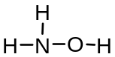?  About N About O
 | A |  | Trigonal pyramidal Bent
 | B |  | Trigonal pyramidal Linear
 | C |  | Trigonal planar Linear
 | D |  | Trigonal planar Bent
6 | A sample of an organic compound of molar mass M is vapourised in a gas syringe and occupies V cm³ at T K and p atm.  What is the density of the compound?
 | A |  | 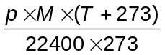 |  |  |  |  |  |  |  | C |  |  |  | 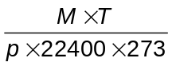
 | B |  | 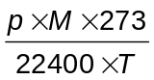 |  |  |  |  |  |  |  | D |  |  |  | 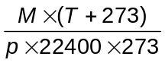
7 | The boiling points of ammonia, hydrogen chloride and carbon dioxide are given below.  Which of the following statements best explains the above data?
  Gas | Formula | Boiling point / ºC
  ammonia | NH₃ | –33
  hydrogen chloride | HCl | –85
  carbon dioxide | CO₂ | –78
 | A |  | NH₃ has a higher boiling point than HCl because the hydrogen bonding in NH₃ is stronger than the permanent dipole–permanent dipole interactions in HCl.
 | B |  | The strength of the induced dipole–induced dipole interactions increases in the order HCl < CO₂ < NH₃.
 | C |  | The strength of the permanent dipole–permanent dipole interactions increases in the order HCl < CO₂ < NH₃.
 | D |  | CO₂ has a higher boiling point than HCl because the permanent dipole–permanent dipole interactions in CO₂ are stronger than the permanent dipole–permanent dipole interactions in HCl.
8 | Hydrogen and iodine vapour exist in equilibrium with hydrogen iodide at a constant temperature in a gas syringe.  H₂ + I₂ 2HI  Which of the following will increase when the pressure is increased at constant temperature? [Assume that the mixture shows ideal behaviour.]
 | A |  | Enthalpy change of reaction
 | B |  | Activation energy
 | C |  | K_{p}
 | D |  | Partial pressure of hydrogen iodide
9 | The diagram shows the Maxwell-Boltzmann energy distribution curves for molecules of a sample of a gas at two different temperatures.  Which letter on the axes represents the most probable energy of the molecules at the lower  temperature?
 | 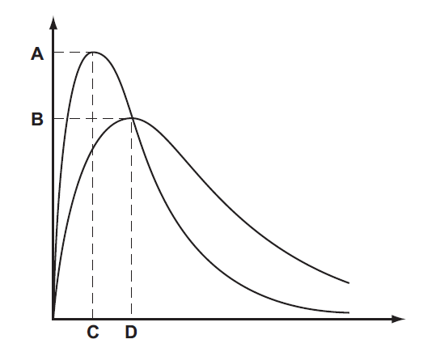
10 | The pK_{b} value for aqueous ammonia at 25 °C is 4.80. What is the pH of a solution containing 100 cm³ of 0.440 mol dm⁻³ aqueous ammonia and 100 cm³ of 0.240 mol dm⁻³ of hydrochloric acid?
 | A | 4.72 |  |  | B |  |  | 4.88 |  |  |  | C |  |  |  | 9.12 |  |  | D |  |  | 9.28
11 | A current of 8 A is passed for an hour through molten aluminium oxide using inert electrodes. What will be the approximate volume of gas liberated, measured at r.t.p.?
 | A | 1.7 dm³ |  |  | B |  |  | 1.8 dm³ |  |  |  | C |  |  |  | 3.3 dm³ |  |  | D |  |  | 3.6 dm³
12 | 2CHClF₂ (g) CF₂=CF₂ (g) + 2HCl (g)  The standard enthalpy changes of formation of HCl (g) is -92.3 kJmol⁻¹, that of CHClF₂ (g) is  -485.2 kJmol⁻¹ and that of CF₂=CF₂ (g) is -658.3 kJmol⁻¹.  Which of the following describes how the yield of CF₂=CF₂ (g) at equilibrium varies as temperature increases?  A B  Yield  temperature  Yield  temperature  C D  Yield  temperature  Yield  temperature
13 | An experiment is set up as shown below to study the corrosion of iron.  Electrode  P  Electrode  Q  Fe  Fe  NaCl(aq)  What will occur at electrodes P and Q?
   | Electrode P | Electrode Q
  A | No corrosion of Fe | Corrosion of Fe  and H₂ gas evolved
  B | No corrosion of Fe | Corrosion of Fe  and O₂ gas evolved
  C | Corrosion of Fe | No corrosion of Fe  and Na deposited
  D | Corrosion of Fe | No corrosion of Fe  and H₂ gas evolved
14 | The common rubber band has some very interesting thermodynamic properties due to its randomly coiled long polymeric molecular structure. When the rubber band is stretched, a slight warming effect is felt.  What are the correct signs of ∆S, ∆H and ∆G if the stretched rubber band is released quickly?
 |  |  | ∆S |  |  |  | ∆H |  |  |  |  |  |  | ∆G
 | A |  | - |  |  |  | - |  |  |  |  |  |  | +
 | B |  | + |  |  |  | - |  |  |  |  |  |  | +
 | C |  | + |  |  |  | + |  |  |  |  |  |  | -
 | D |  | - |  |  |  | + |  |  |  |  |  |  | -
15 | Three substances, R, S, T, have physical properties as shown.  What could be the identities of R, S and T?
  substance | mp/⁰C | bp/⁰C | electrical conductivity
  substance | mp/⁰C | bp/⁰C | of solid | of liquid
  R  S  T | 801  2852  3550 | 1413  3600  4827 | poor  poor  good | good  good  not known
 |  |  | R |  |  |  | S |  |  |  |  |  |  | T
 | A |  | NaF |  |  |  | KCl |  |  |  |  |  |  | Cu
 | B |  | NaBr |  |  |  | BaO |  |  |  |  |  |  | SiO₂
 | C |  | NaCl |  |  |  | MgO |  |  |  |  |  |  | C[graphite]
 | D |  | NaBr |  |  |  | CaO |  |  |  |  |  |  | C[diamond]
16 | Which graph represents the number of unpaired p orbital electrons for atoms with proton numbers 13 to 18?  A  B  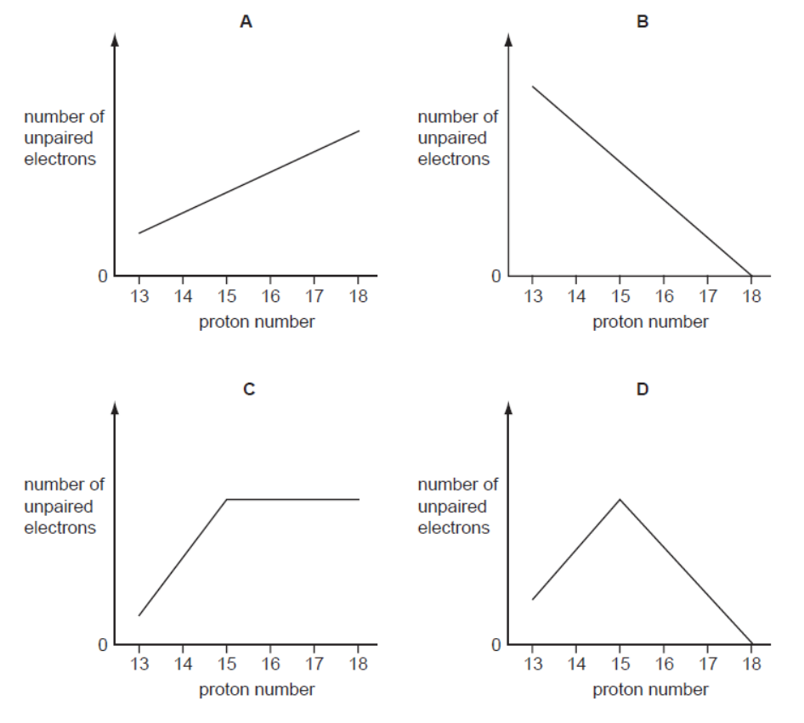  C  D
17 | The table shows the possible oxidation states of five d-block elements in the Periodic Table. (The elements are represented by the letters which are not their symbols.)  Which of the following ions is likely to exist?
  element | possible oxidation numbers
  W | - | 2 | 3 | 4 | - | - | -
  X | 1 | 2 | 3 | 4 | 5 | - | -
  Y | - | - | 3 | 4 | 5 | 6 | -
  Z | - | 2 | - | 4 | 5 | 6 | 7
 | A |  | WO₃⁻ | B |  | XO₄²⁻ |  |  |  | C |  |  | YO₄⁻ |  |  |  |  | D |  |  | ZO₂²⁺
18 | Dilute sulfuric acid was added to aqueous barium hydroxide until the acid was in excess.  Which graph shows the variation in the total number of ions in solution?  Number of ions C  Number of ions A  0  amount of acid added  Number of ions D  Number of ions B  0  amount of acid added  0  amount of acid added  0  amount of acid added
19 | The compound [Co(NH₃)₅Br]SO₄ is isomeric with the compound [Co(NH₃)₅SO₄]Br. What is the oxidation state of cobalt in these compounds?
 |  |  | [Co(NH₃)₅Br]SO₄ |  |  |  |  |  | [Co(NH₃)₅SO₄]Br
 | A |  | +3 |  |  |  |  |  | +3
 | B |  | +2 |  |  |  |  |  | +1
 | C |  | +3 |  |  |  |  |  | +2
 | D |  | +2 |  |  |  |  |  | +3
20 | Mohr’s salt is a pale green crystalline solid which is soluble in water. It is a ‘double sulfate’ which contains two cations.  The identity of the cations can be determined by heating solid Mohr’s salt with solid sodium hydroxide. A colourless gas and a grey green solid residue were formed. The gas evolved readily dissolved in water giving an alkaline solution and the residue formed was insoluble in water.  What are the identities of the gas and the solid residue?
 |  |  | gas |  |  |  |  |  | residue
 | A |  | H₂ |  |  |  |  |  | FeSO₄
 | B |  | NH₃ |  |  |  |  |  | Na₂SO₄
 | C |  | NH₃ |  |  |  |  |  | Fe(OH)₂
 | D |  | SO₂ |  |  |  |  |  | Fe(OH)₂
21 | Which of the following synthetic routes does not produce ethanoic acid?
 | A
 | B
 | C |  | 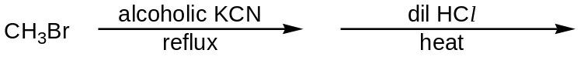
 | D |  | 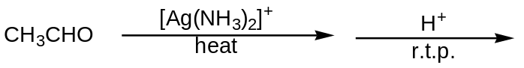
22 | What reagent can be used to distinguish between the following isomers?  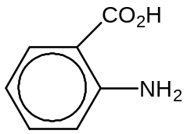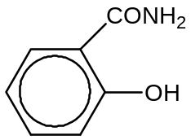
 | A |  | Aqueous NaOH, heat
 | B |  | Na metal, room temperature and pressure
 | C |  | Aqueous bromine, room temperature and pressure
 | D |  | LiAlH₄, dry ether, room temperature and pressure
23 | The uncatalysed addition of HCN to a carbonyl group to give a cyanohydrin proceeds by two steps.  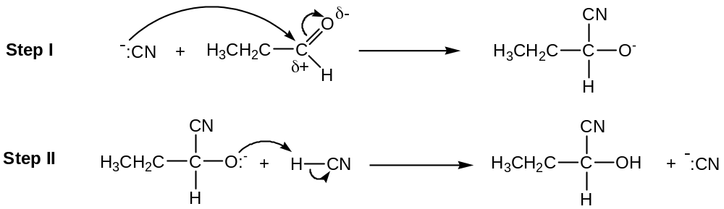  The rate equation for the formation of cyanohydrin is as follows.  Rate = k[CH₃CH₂CHO][CN⁻]  Which of the following statements is correct?
 | A |  | Step II is rate determining.
 | B |  | The reaction will proceed slower if small amount of NaOH is added.
 | C |  | A same product can be obtained by refluxing 1-chloropropan-1-ol with HCN.
 | D |  | The uncatalysed addition of HCN to propanone occurs at slower rate than that for propanal.
24 | Compound X shows the following chemical properties.  I) It does not give any observation with Fehling’s solution.  II) 1 mole of compound X reacts with 2 moles of sodium metal.  III) When PCl₅(s) is added to compound X, a sweet smelling product is obtained.  Which of the following structures can compound X be?
 | A |  | HO₂CCH₂CH₂CH₂CO₂H
 | B |  | HO₂CCH₂CH₂CH₂CHO
 | C |  | 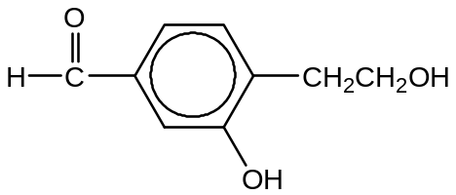
 | D |  | 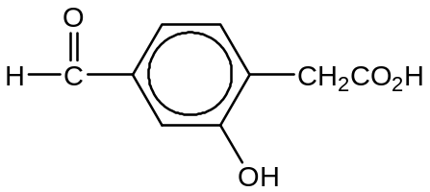
25 | Which of the following shows the correct order of increasing acidity?
 | A |  | 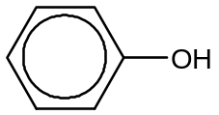 < 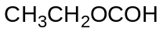 < 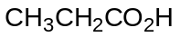 < 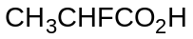
 | B |  | < < <
 | C |  | < < <
 | D |  | < < <
26 | 1,2-dibromo-3-chloropropane (DBCP) has been used in the control of earthworms in agricultural land. Which of the following would be the best synthesis of this compound?
 | A |  | CH₃CH₂CH₂Cl + 2Br₂ → DBCP + 2HBr
 | B |  | CH₂BrCHBrCH₃ + Cl₂ → DBCP + HCl
 | C |  | ClCH₂CH=CH₂ + PBr₅ → DBCP + PBr₃
 | D |  | CH₂=CHCH₂Cl + Br₂ → DBCP
27 | α-Cadinene is present in the oil derived from the plant juniper woods. X is the major compound when α-Cadinene is reacted with HBr in CCl₄. How many chiral carbons does X have?  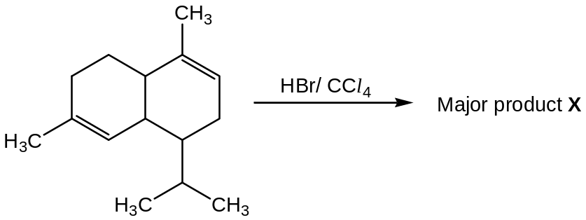
 | A | 3 |  |  | B |  |  | 4 |  |  |  | C |  |  |  | 5 |  |  | D |  |  | 6
28 | The structure of the alkaloid ephedrine is shown below.  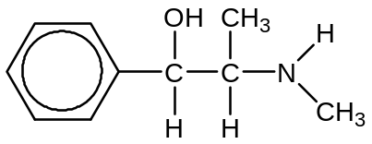  Which of the following will be properties of the alkaloid?
 | A |  | It reacts with excess concentrated H₂SO₄ at 180°C to give a chiral product.
 | B |  | It gives a violet complex with neutral FeCl₃.
 | C |  | When warmed with acidic KMnO₄, its product gives a silver mirror with Tollen’s reagent.
 | D |  | 0.2 mol of ephedrine reacts with 0.1 mol of HCl(aq) to give a buffer solution.
29 | Four drops of 1-chorobutane, 1-bromobutane and 1-iodobutane were put separately into three test-tubes containing 1.0 cm³ of aqueous silver nitrate at 60°C.  A hydrolysis reaction occurred. (R represents the butane chain C₄H₉ – and X the halogen atom.)  H₂O(l) + R–X(l) + Ag⁺(aq) → R–OH(aq) + AgX(s) + H⁺(aq)  The rate of formation of cloudiness in the tubes was in the order RCl < RBr < RI. Why is this?
 | A |  | The R-X bond polarity decreases from RCl to RI.
 | B |  | The solubility of AgX(s) decreases from AgCl to AgI.
 | C |  | The ionisation energy of the halogen decreases from Cl to I.
 | D |  | The bond energy of R-X decreases from RCl to RI.
30 | Ethanol reacts explosively with sodium metal to form a salt, sodium ethoxide. What is the product of the reaction between 2-iodobutane and sodium ethoxide?
 | A |  | CH₃CH=CHCH₃
 | B |  | (CH₃)₂CHCH₂OCH₂CH₃
 | C |  | CH₃CH₂CH(OCH₃)CH₂CH₃
 | D |  | CH₃CH₂CH(CH₃)OCH₂CH₃

Section B
For each of the questions in this section, one or more of the three numbered statements 1 to 3 may be correct.
Decide whether each of the statements is or is not correct (you may find it helpful to put a tick against the statements which you consider to be correct).
The responses A to D should be selected on the basis of
A | B | C | D
1, 2 and 3  are correct | 1 and 2  only are correct | 2 and 3  only are correct | 1 only is correct
No other combination of statements is used as a correct response.
31 |  | Which of the following statements are correct for a solution saturated with both AgCl and AgBr if their solubilities (in mol dm⁻³) in separate solutions are x and y respectively? (Assume all solutions are at the same temperature)
 |  | 1 |  | [Ag⁺] = x + y
 |  | 2 |  | [Br⁻] < y
 |  | 3 |  | [Ag⁺] = [Br⁻] + [Cl⁻]
32 |  | Consider the following changes:  ∆H₁: M(s) → M(g)  ∆H₂: M(s) → M²⁺(g) + 2e⁻  ∆H₃: M(g) → M⁺(g) + e⁻  ∆H₄: M⁺(g) → M²⁺(g) + e⁻  ∆H₅: M(g) → M²⁺(g) + 2e⁻  The second ionisation energy of M could be calculated from the energy values associated with
 |  | 1 |  | ∆H₁ + ∆H₅
 |  | 2 |  | ∆H₅ - ∆H₃
 |  | 3 |  | ∆H₂ - ∆H₁ - ∆H₃
33 |  | Ammonia and chlorine react in the gas phase.  8NH₃ + 3Cl₂ → N₂ + 6NH₄Cl  Which statements are correct?
 |  | 1 |  | Ammonia behaves as a reducing agent.
 |  | 2 |  | Ammonia behaves as a base.
 |  | 3 |  | The oxidation number of the hydrogen changes.
34 | In black and white photographic film, light converts silver chloride into metallic silver. After the film has been developed, the unreacted silver chloride is removed by reaction with sodium thiosulfate to produce a ‘fixed’ negative. The function of thiosulfate ion is similar to that of ammonia.  What is the function of the thiosulfate ion?
 | 1 |  | To lower the concentration of silver ions.
 | 2 |  | To form complex with silver ions.
 | 3 |  | To reduce the silver ions to silver.
35 |  | Which properties would be expected for the Group II element, strontium, or its compounds?
 |  | 1 |  | When heated in oxygen, strontium does not burn.
 |  | 2 |  | On being heated, strontium carbonate decomposes to give strontium oxide.
 |  | 3 |  | When strontium oxide is added to water, the solution is alkaline.
36 |  | Propanone and hydrazine can react to form hydrazine derivatives as shown below:  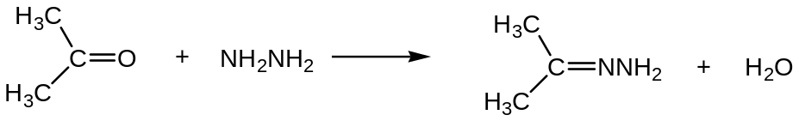  The reaction involves addition reaction, followed by elimination. Which of the following are possible steps in the reaction?
 |  | 1 |  | 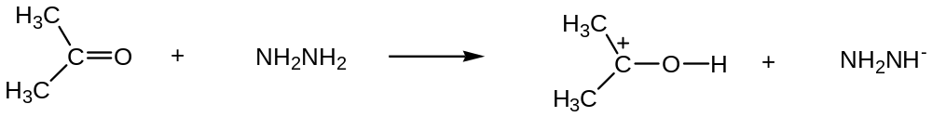
 |  | 2 |  | 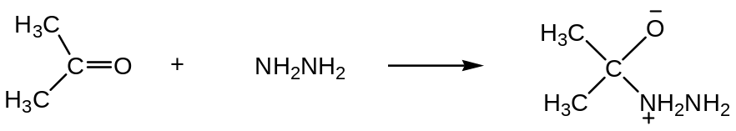
 |  | 3 |  | 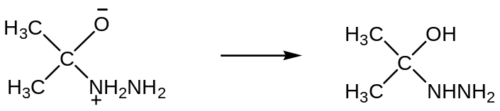
37 |  | Which statements about the following reaction sequence are correct?  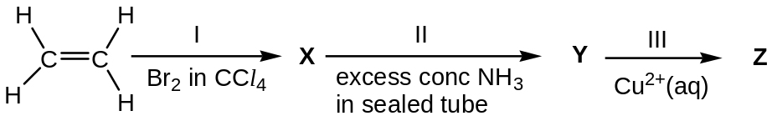
 |  | 1 |  | Compound X is 1,2-dibromoethane
 |  | 2 |  | Step II involves nucleophilic substitution
 |  | 3 |  | Step III involves ligand exchange
38 |  | Which of the following reactions give products that do not rotate the plane of polarised light?
 |  | 1 |  | Propene reacted with bromine dissolved in organic solvent.
 |  | 2 |  | Ethanal reacted with HCN, trace NaOH, 10 – 20°C.
 |  | 3 |  | 3-chloro-3-methylhexane refluxed with aqueous KOH.
39 |  | When a compound W was heated in the tube containing reagent X, a colour change was observed in the tube. A precipitate was noted when reagent Y was heated with the products from reaction of W and X. Which of the following combinations could be W, X and Y?
 |  |  |  | W X Y
 |  | 1 |  | CH₂=CH₂ aqueous bromine CH₃CO₂⁻Ag⁺
 |  | 2 |  | CH₂=CHCH₃ acidified KMnO₄(aq) Fehling’s solution
 |  | 3 |  | CH₃CH₂Br NaOH(aq) alkaline aqueous iodine
40 |  | The following compound, Z, is a by-product formed in the body that counteracts the effect of the drug administered to patients to treat herpes.  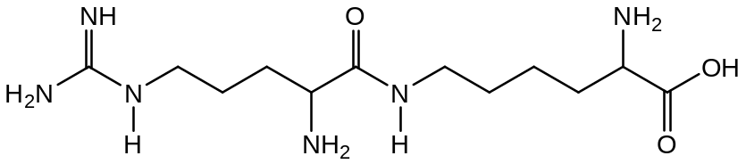  Which of the following statements about this compound are correct?
 |  | 1 |  | Z undergo nucleophilic substitution with chloroethane
 |  | 2 |  | One mole of Z can be hydrolyzed to produce 2 moles of amino acids
 |  | 3 |  | When an aqueous solution of Z at pH 3 is analysed by electrophoresis, it is found near the anode

Answers to 2010 TJC H2 Chem Prelim P1
1 | C | 11 | B | 21 | B | 31 | C
2 | D | 12 | A | 22 | A | 32 | C
3 | B | 13 | D | 23 | D | 33 | B
4 | D | 14 | C | 24 | D | 34 | B
5 | A | 15 | C | 25 | B | 35 | C
6 | B | 16 | D | 26 | D | 36 | C
7 | A | 17 | D | 27 | C | 37 | A
8 | D | 18 | C | 28 | D | 38 | A
9 | C | 19 | A | 29 | D | 39 | D
10 | C | 20 | C | 30 | D | 40 | B

